**User Manual**  
EAE DALI Commissioning Master v1.4.0



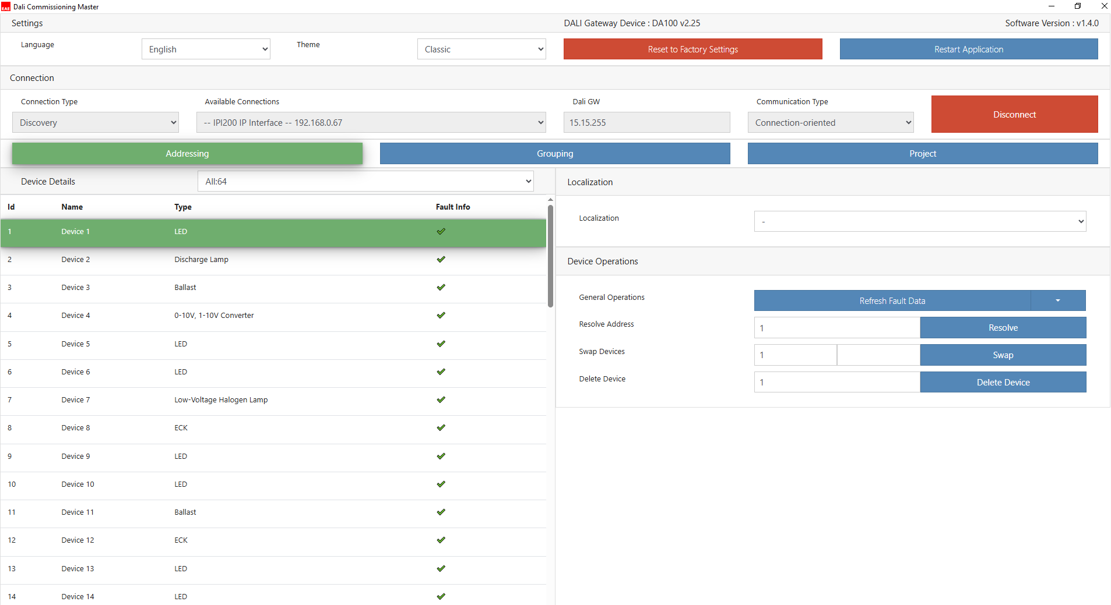

Table of Contents

1. General 3

2. Settings 4

2.1 Language 4

2.2 Themes 4

2.3 Reset to Factory Settings 4

2.4 Restart Application 5

3. Connection 6

3.1 Connection Type 6

3.2 Dali GW 6

3.3 Communication Type 6

3.4 Connect 7

4. Addressing 8

4.1 Device Details 8

4.2 Localization 11

4.2.1 Individual Control 11

4.2.2 Optic Feedback 12

4.3 Device Operations 13

5. Grouping 14

6. Project 16

# 1. General

This Windows desktop application is used to configure DA100 and DA110  KNX-DALI Gateway devices.

# 2. Settings



Settings

## 2.1 Language

The application supports two languages: Turkish and English.

Device fault codes (e.g., Device Offline, Open Circuit) and device types(e.g., Ballast, ECK, LED) are always displayed in English, regardless of the selected language. When the language is changed, the application automatically restarts.

## 2.2 Themes

The application has two theme modes: Classic and Dark.

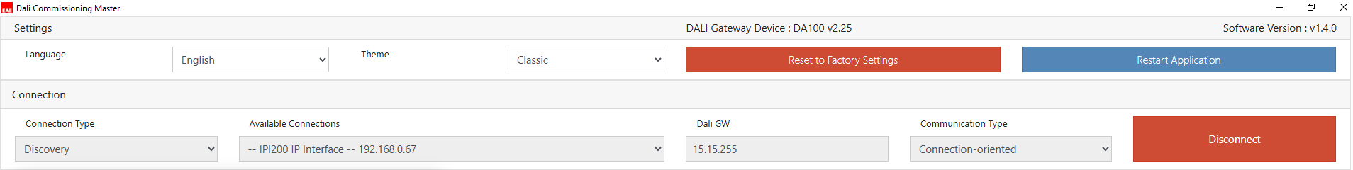

Classic Mode

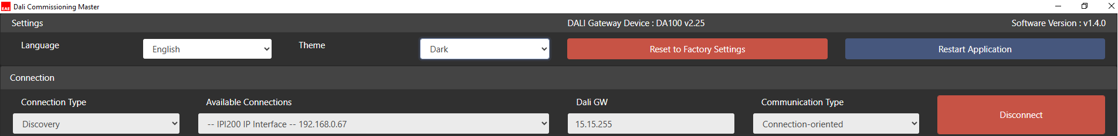

Dark Mode

## 2.3 Reset to Factory Settings

When this button is clicked, a confirmation dialog appears.

If confirmed, the following actions are performed (note: these changes apply only to the application and do not send any commands to the device or DALI line):

* Deletes project files configured in the **Project** tab
* Clears session data (e.g., saved connections, theme and language selections)
* Removes group and device lists from the application
* The application restarts, and any active KNX connection is disconnected during the process

## 2.4 Restart Application

When this button is clicked, the application automatically restarts without confirmation. Any active KNX connection is disconnected during the process.

# 3. Connection

## 3.1 Connection Type

There are two connection types: Discovery and Manual.

1. **Discovery**: The application automatically scans available IP interfaces/routers (Ethernet, Wi-Fi) and connected USB devices. When the "Available Connections" dropdown is clicked, all discovered devices are listed. Discovery is typically the default connection mode.

Connections are not automatically refreshed after the scan is complete. If a new interface is added after the initial scan, the user must click the “Restart Application” button to reinitialize the discovery process and update the available connections.

Discovered Connections

1. **Manual (IP)**:  The user selects the correct local network adapter and enters the Interface/Router IP address. This method is useful when the PC and the KNX IP interface or router are on different networks.

Manual (IP)

## 3.2 Dali GW

Input field for entering the physical address of the KNX-DALI gateway device (e.g., 15.15.255).

## 3.3 Communication Type

There are two communication types: Connection-oriented and Connectionless.

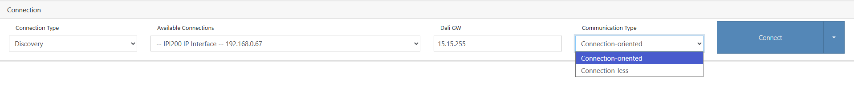

Communication Types

1. **Connection-oriented**: The established connection constitutes a logical link between two communication partners. Both partners regard this connection as a link that only exists between them (point-to-point connection) and that can only be used by them. **This is the default and recommended communication type**.
2. **Connectionless**:  There is no confirmation of the data received and the device sending the information does not guarantee the correct order of the transmitted data blocks. However, connectionless communication speeds up the processes, especially for DA110 devices, by reducing the number of telegrams. You may consider using this mode if you experience issues with connection-oriented communication.

## 3.4 Connect

There are three “connect” options for establishing a connection with a KNX-DALI gateway device:

1. **Connect**: Establishes only a basic connection to a KNX-DALI gateway device. This is the default option.
2. **Connect With Initial Value**: After a successful connection, the application queries device and group information.
3. **Connect With Initial Value and Fault Info**:  In addition to device and group information, fault data is also queried after connection.

# 4. Addressing

## 4.1 Device Details

After a successful connection to the device, the KNX-DALI gateway device can be queried for device count, device type, and fault information. This can be done either by using “**Connect with Initial Value and Fault Info**”, or by performing a basic connection followed by selecting “**Refresh Fault Data**” under “**Device Operations > General Operations”**.

Device Details

* **Id**: Represents both the order and the DALI short address of the device.  
  **Id = Short Address + 1**  
  *(e.g., ID 3 corresponds to Short Address 2)*
* **Name**: When a device is queried, it is automatically named as “Device” (e.g., Device 1, Device 2). The name appears in a table cell and can be edited by double-clicking it. This change is also reflected on the grouping page.  
  The name is managed entirely within the application and is **not saved to the KNX-DALI gateway device**. If the connection is lost, device information—including the name—will be discarded.
* **Type**: Device types are listed below.  If a device type is not recognized or supported, it will be displayed as **“undefined-DTX”** (e.g., *undefined-DT8*, *undefined-DT9*) or simply “**undefined**”. **DT** stands for **Device Type** in DALI terminology.

|  |  |  |  |
| --- | --- | --- | --- |
| **NAME** | **DT** | **Supported DA100 Firmware Version** | **Supported DA110 Firmware Version** |
| Ballast | 0 | ALL | ALL |
| ECK | 1 | ALL | N/A |
| Discharge Lamp | 2 | 2.25 or greater | 2.2 or greater |
| Low-Voltage Halogen Lamp | 3 | 2.25 or greater | 2.2 or greater |
| Incandascent Lamp Dimmer | 4 | 2.25 or greater | 2.2 or greater |
| 0-10V, 1-10V Converter | 5 | 2.25 or greater | 2.2 or greater |
| LED | 6 | ALL | ALL |
| Multi Sensor | 100 | ALL | N/A |
| MSensor | 254 | ALL | N/A |

* **Fault Info**: Fault types are listed below. A checkmark sign means no fault.

|  |  |  |
| --- | --- | --- |
| **NAME** | **DT** | **FAULT TYPE** |
| Ballast | 0 | Device Offline Ballast Fault Lamp Fault |
| ECK | 1 | Device Offline Ballast Fault Lamp Fault Emergency Kit Fault Circuit Failure Battery Duration Failure Battery Failure Emergency Lamp Failure Functional Test Max Delay Exceeded Duration Test Max Delay Exceeded Functional Test Failure Duration Test Failure |
| Discharge Lamp | 2 | Device Offline Ballast Fault Lamp Fault |
| Low-Voltage Halogen Lamp | 3 | Device Offline Ballast Fault Lamp Fault |
| Incandascent Lamp Dimmer | 4 | Device Offline Ballast Fault Lamp Fault |
| 0-10V, 1-10V Converter | 5 | Device Offline Ballast Fault Lamp Fault |
| LED | 6 | Device Offline Ballast Fault Lamp Fault LED Fault Short Circuit Current Protector Active Open Circuit Load Decrease Load Increase Reference Measurement Failed Thermal Shutdown Thermal Overload |
| Multi Sensor | 100 | Device Offline Ballast Fault Lamp Fault |
| Msensor | 254 | Device Offline Ballast Fault Lamp Fault |

A dropdown list is also available for device types and fault types as well. It provides filtering functionality.

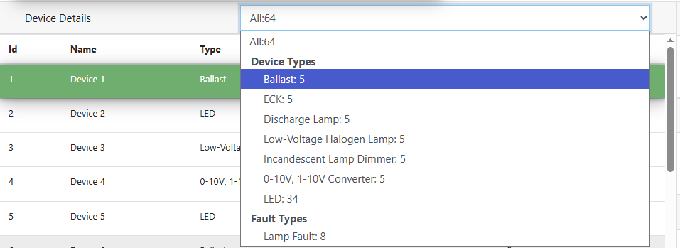

Device Types and Fault Types

## 4.2 Localization

### 4.2.1 Individual Control

This feature is used to test lamps individually. Select the desired lamp before performing any action. Below are the actions except ECK.

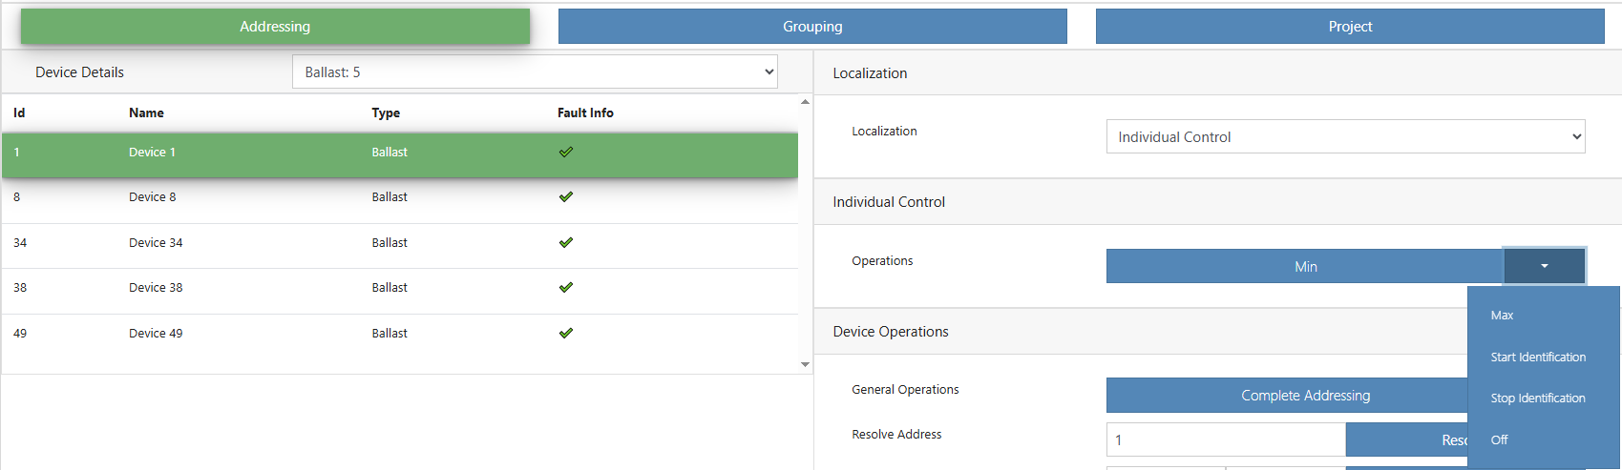

Individual Control Actions (Except ECK)

|  |  |
| --- | --- |
| **Actions (Except ECK)** | **Description** |
| Min | Selected lamp will be dimmed to minimum level |
| Max | Selected lamp will be dimmed to maximum level. |
| Off | Selected lamp will be switched off. |
| Start Identification | Selected lamp will start blinking. |
| Stop Identification | Selected lamp will stop blinking. |

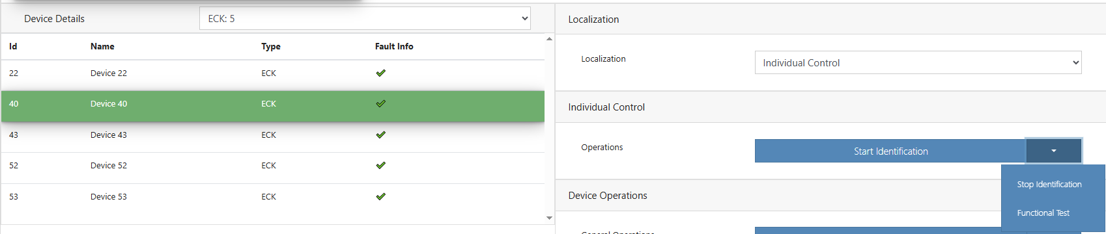

Individual Control Actions (ECK)

|  |  |
| --- | --- |
| **Actions (ECK)** | **Description** |
| Start Identification | Selected ECK will start blinking. |
| Stop Identification | Selected ECK will stop blinking. |
| Functional Test | Selected ECK will start functional test. This command checks the operation of the lamp, battery, circuit and changeover relay/drive circuit. |

### 4.2.2 Optic Feedback

This feature allows you to control selected and unselected lamps simultaneously, making it easier to identify the desired lamp. **The desired lamp should be selected after choosing the action**.

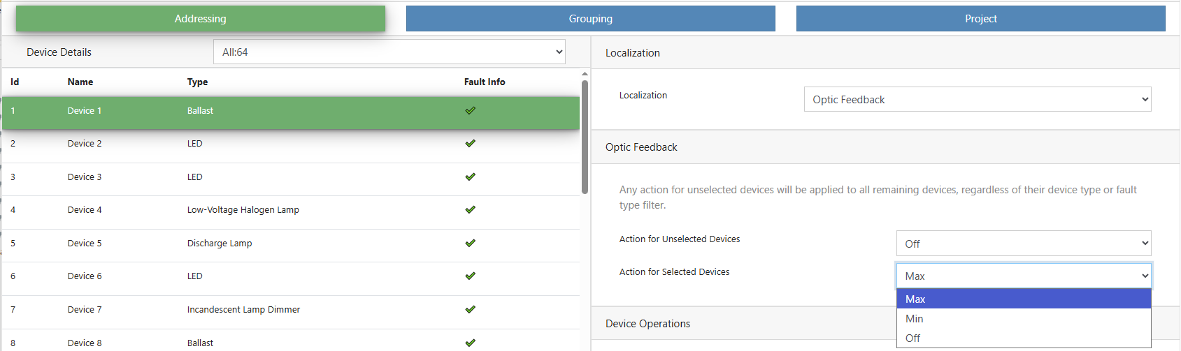

Optic Feedback Actions

|  |  |
| --- | --- |
| **Actions** | **Description** |
| Min | Selected/Unselected lamps will be dimmed to minimum level. |
| Max | Selected/Unselected lamps will be dimmed to maximum level. |
| Off | Selected/Unselected lamps will be switched off. |

## 4.3 Device Operations

|  |  |
| --- | --- |
| **General Operations** | |
| Complete Addressing | Used to assign addresses to all devices on the DALI line. All devices will be addressed, regardless of whether they have already been assigned an address. |
| New Device Addressing | Used to assign addresses only to unaddressed devices on the DALI line. Devices that already have an address will not be affected. |
| Capture Field | Used to scan devices and collect their data on the DALI line.  If there is an address conflict in the DALI ballasts, DA110 automatically performs the address conflict resolution process. While resolving the address conflict, unaddressed ballasts on the DALI line are also automatically addressed. If there is no address conflict, only the ballast data is retrieved. |
| Start Test Installation | Blinks all devices on the DALI line for identification purposes. |
| Stop Test Installation | Stops blinking and switches all devices on. |
| Refresh Device Data | Retrieves device data from the KNX-DALI gateway. |
| Refresh Fault Data | Retrieves device data from the KNX-DALI gateway, including fault information. |

|  |  |
| --- | --- |
| Swap | This function is used to exchange addresses between two devices of the same type. It can also be used to assign a new, unused address to a device. **Note:** Address 64 must be free for this function to work. |
| Delete Device | This function removes the specified device address. **Note:** Address 64 must be free for this function to work. |

|  |  |
| --- | --- |
| Resolve | This function is used to fix address conflicts. The conflicting address must be entered in the input field. Once the process is complete, the conflicted address will be removed and a new address will be automatically assigned to the affected device.  **DA100 – Conflict Resolution Behavior Change (v2.25)** Prior to version 2.25, resolving conflicting addresses on the DA100 device would automatically remove the affected devices from their groups. Starting with version 2.25, this behavior has been updated: a pop-up dialog now appears with a checkbox option. If the checkbox is not selected, the conflicting addresses will remain in their groups.  After resolving an address conflict, the device name may appear differently in the group view for the affected devices. |

Resolving Conflicts

# 5. Grouping

This page is used to add devices to the groups. DA100 supports grouping operations.

ECK and undefined devices are not groupable.

* Devices can be selected with a **left-click**. To select a range of devices, hold **Shift** and left-click on the desired items in the device list—this works both upward and downward.
* Once the selection is complete, **left-click** on one of the selected items, then **drag and drop** them into the desired group table.

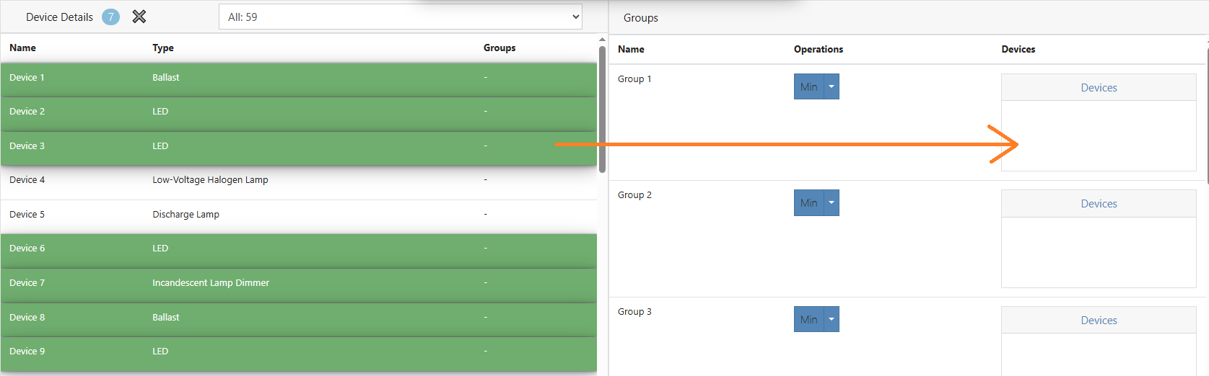

Grouping Drag and Drop

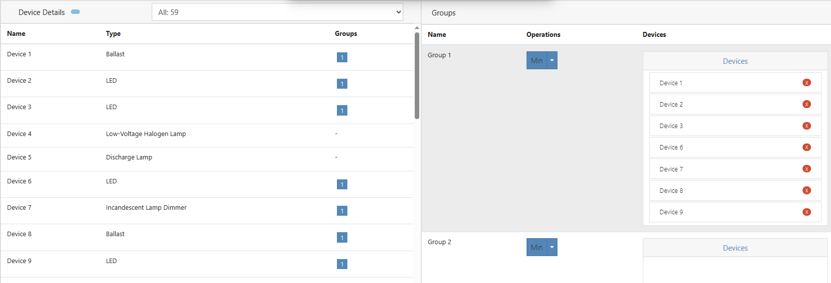

Grouping After Drop

Grouped devices can be tested with the following actions.

|  |  |
| --- | --- |
| **Actions** | **Description** |
| Min | Grouped devices will be dimmed to minimum level. |
| Max | Grouped devices will be dimmed to maximum level. |
| Off | Grouped devices will be switched off. |

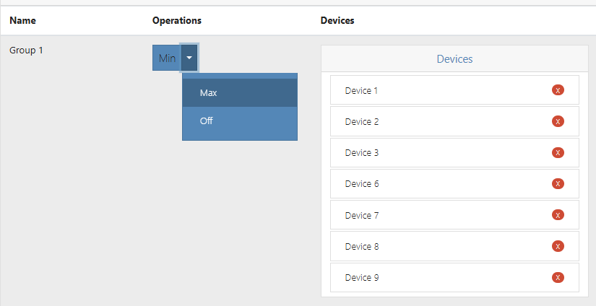

Grouping Multicast Operations

Once a device has been added to a group, it can also be removed. Devices must be removed individually from the

group.

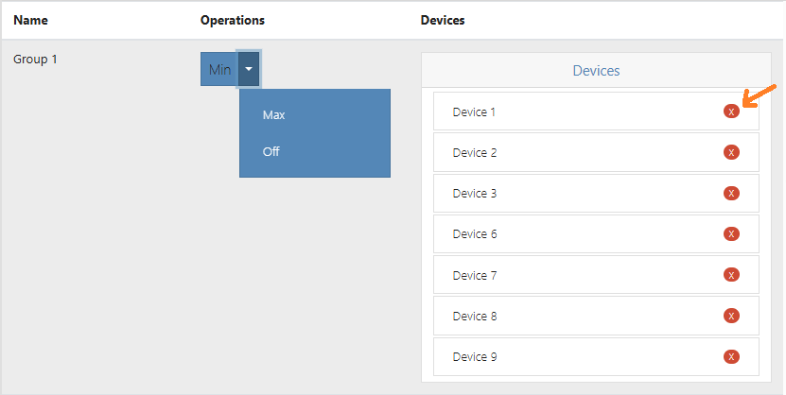

Remove The Device from Groups

# 6. Project

Project Page

|  |  |
| --- | --- |
| **Actions** | **Description** |
| Add Current Device | Allows entering a name for the DALI Gateway. Once the device is added, its physical address, group information and detailed device list are displayed together on a single page for reference only. |
| Import | Used to import a .dalitool file, which contains the DALI Gateway device and group lists. These files are generated by the application using the **Export .dalitool** button.  Note: Importing a .dalitool file only loads the data into the application. **No changes are made to the actual DALI Gateway.** This feature is intended solely for viewing and reference within the application. Users should not expect any configuration or data to be transferred to the DALI gateway device. |
| Export .dalitool | Used to export the device and group list in the **.dalitool** format. This file can later be re-imported using the **Import** function. |
| Export .csv | Used to export the device and group list in CSV format, compatible with Excel for easy viewing and editing. |